# Homework 4 HTML and CSS

# Below is an extract from a website:

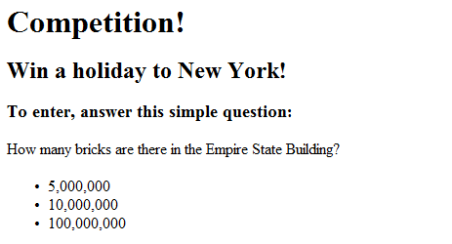

(a) Some of the HTML code for this page is listed below. Fill in the missing lines of HTML code needed in order to display this page correctly. [5]

<!doctype html>

<html>

<head>

Competition

</head>

<body>

<h1>Competition</h1>

<h2>Win a holiday to New York!</h2>

<h3>To enter, answer this simple question:</h3>

<ol>

<li>5,000,000</li>

<li>10,000,000</li>

<li>100,000,000</li>

</ol>

</body>

</html>

(b) An image could be added to the web page to improve its appearance.

Write a line of HTML code to include the image ‘empirestate.jpg’ [2]

1. The web page has had a Cascading Style Sheet (CSS) file, **Competition.css,** applied to improve the appearance. The HTML code required to link the external CSS file is incomplete:

< **1** rel=" **2** " type = "text/css" href=" **3** "/>

Complete the table below by writing the missing parts of the HTML code. [3]

|  |  |
| --- | --- |
| **Label** | **Missing code** |
| **1** | Link |
| **2** | stylesheet |
| **3** | Styles.css |

1. A web developer is writing a CSS file to improve the appearance of their web pages. They would like all of their div elements to have a black background with a thick, red border. The font should be size 22px and centered.

Complete the CSS file below to reflect the requirements mentioned above. [5]

div {

background: black

border-color: red

font-size: 22px;

border-style: single;

text-align: centre;

}

Total 15 Marks